Request:

**ASR Inbound Container Weekly summary by ETA**

Date: 18 Nov 2014

Requestor: Yeo, Ming Fong

Description:

Weekly Inbound container Summary by ETA Date range

Report criteria parameter: From ETA Date, To ETA Date.

The report will generate a summary of no of inbound container by container location and status as below format:

|  |  |  |  |  |  |  |  |  |  |
| --- | --- | --- | --- | --- | --- | --- | --- | --- | --- |
| Week# | SLC  Total | SLC  GR Completed | SLC  Pending GR | SLC  At Port | TLC  Total | TLC  GR Completed | TLC  Pending  GR | TLC  At Port | Overall  Total |
| 46 | 30 | 30 | 0 | 0 | 52 | 51 | 1 | 0 | 82 |
| 47 |  |  |  |  |  |  |  |  |  |

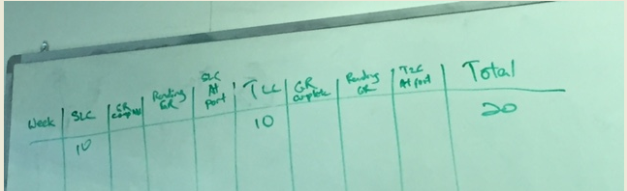

New Report added to WMS:

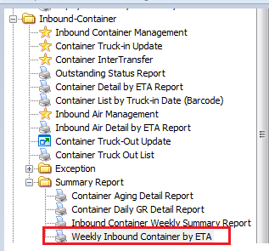

Retrieve by ETA date range

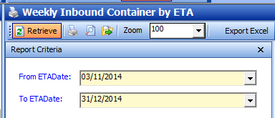

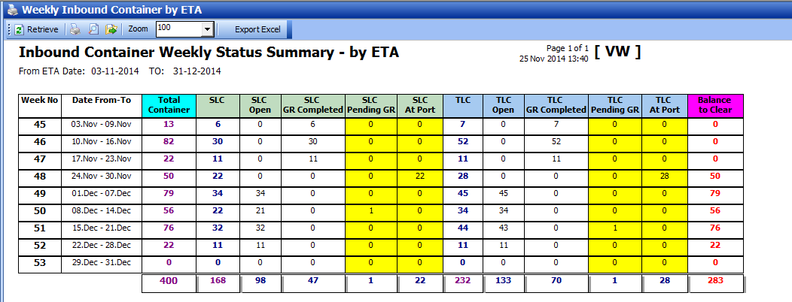

[updated 2014.12.18]

* Add # of Line for SLC and TLC

